**Question 1**

(a) In the context of HCI, explain the meaning of evaluation. Give 3 reasons why it is important to evaluate systems.

It is about assessing the usability of a system.

* To ensure that people **can use** the system/product, so that they will **like it**
* To allow designers to concentrate on **real problems** rather than imaginary one
* To provide a means for suggesting improvements based on the feedback obtained from the user
* To ensure that problems are fixed before the system/product is shipped out, the systems is deployed in the real environments
* Assess extent of system functionality
  + it must match with the user’s requirements.
  + matching the use of the system to the user’s expectations of the task they need to performed with the systems
* Assess effect of interface on user (usability)
  + This includes considering aspects such as how easy the system is to learn, its usability and the user’s satisfaction with it.
  + enjoyment and emotional response (application for leisure & entertainment purpose)
* Identify specific problems
  + At the aspects of the design which, when used in their intended context, cause unexpected results, or confusion amongst users.

(b) What are the methods that a designer can use to evaluate the usability of a product/system/software?

* Survey Questionnaires survey form & Interviews the users,
* Expert reviews the systems using heuristics evaluation & cognitive walkthrough,
* Observation by observing users in the field study & usability lab test, for example install web camera on the users computers to observed the user behaviours.

**Question 2**

1. In HCI, questionnaires have long been used to evaluate user interfaces. Discuss 2 advantages and 2 disadvantages of using questionnaires as a technique of evaluation.

* Advantages
  + quick and reaches large user group via email
  + can be analyzed more systematic , question by questions
* Disadvantages
  + less flexible compared with interviews
  + less probing, less interaction compared with interviews
  + Require skill to producea **good questionnaire**
  + **Cannot use too many open ended questions**
  + Poor returned rates, responds from the respondents

1. One of the issues of using questionnaires is poor returned rates. Suggest 2 solutions to overcome this problem.

* Avoid busy periods such as holiday.
* Contact potential participants personally for a few times.
* Create a participant friendly questionnaire such as limiting number of questions, providing clear instructions, avoid essay questions.
* Use technology for convenience such as online questionnaire.
* Conducting questionnaire on phone.
* Provide incentives or gifts for answering the questionnaires

**Question 3**

(a) Analyse the questionnaire given below and then redesign the questionnaire to improve it. You must show at least 4 improvements in your answer. Give reasons for your answer.

*(Note: Do NOT change the last question i.e. let it be an open question)*

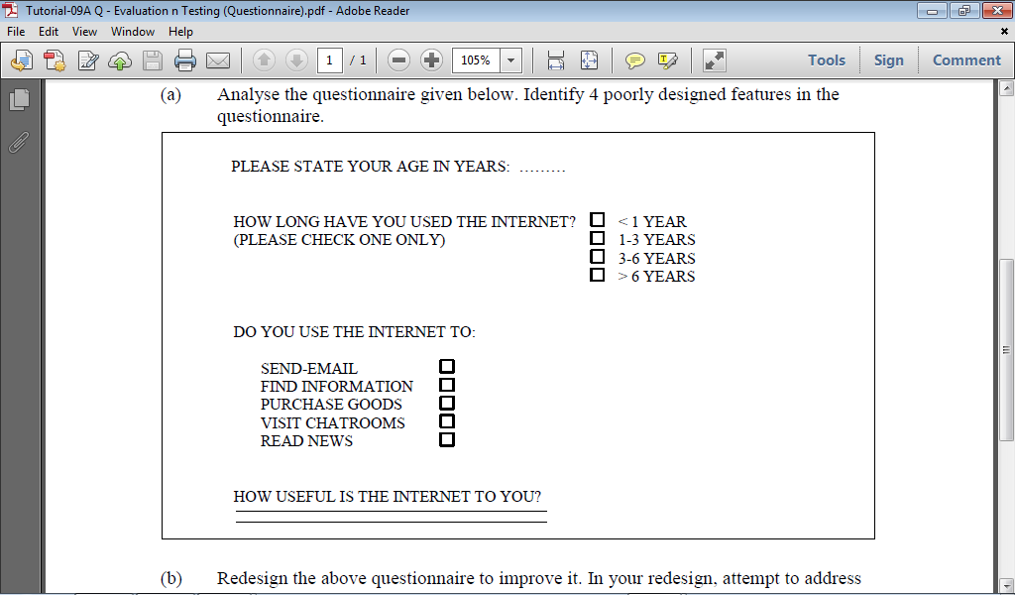

* Age fields – standardized with underline, do not use …. OR use age range check box
* How long used internet – 1-3 or 3-6 years. 3 is in both options, if the user need to answer 3 years which one should the user check
* Do you use internet – standardized with checkboxes on left, these checkboxes should be placed on the left, follow the above questions layout
* How useful is the internet – Add more vertical spaces for each line. For the user to write, its been suggested to avoid essay questions, instead closed ended MCQ will be better here.
* Capital letter to lower case letter.
* Title of the form missing, the user might not know the purpose of the filling in the form.

1. Suggest a cost effective way to evaluate the usability of the Google Classroom. Justify your answer. Include also in your answer the steps to be followed to carry out the evaluation.

Use of the questionnaire survey since it is easy to administer and can send to a large population by just distributing online questionnaires to them via e-mail.

* Advantages
  + quick and reaches large user group via email
  + can be analyzed more systematic , question by questions

## In general, the steps can be as follows:

## Decide on the target population and sample size

## who do you want to ask and how many

## Develop the questions

## Pre-test the questionnaire

## Conduct the survey

## Collect data and Analyze data collected